Flooding Information for the Townships of Hammonton and Evesham
By: Pinelands Preservation Alliance

Introduction

This document, prepared by the Pinelands Preservation Alliance, assesses the potential flood damage in the towns of Evesham and Hammonton based on Burlington County's Multi-Jurisdictional Hazard Mitigation Plan Update of 2013. Key factors include the number of historical flooding events, the value of property exposed in flood zones, and the number of residents who would be displaced in a serious flood event.

Evesham
Info from DMA 2000 Hazard Mitigation Plan Update (2013) – Burlington County, New Jersey (SECTION 5.4.4: RISK ASSESSMENT – FLOOD)
Link to report: http://www.co.burlington.nj.us/DocumentCenter/View/859/Draft-Section-544---Flood-PDF
- Report states that flooding occurs in areas where culvert openings are inadequate to handle discharge and where debris at structures restricts the flow. Increasing development within the Township has aggravated flooding along Barton Run near Kenilworth Lake, the upstream reach of Rancocas Creek South Branch and the downstream reach of Pennsauken Creek South Branch

- the Township reported that roadways commonly impacted by flooding include the Old Marlton Pike, Route 73 at Baker, Route 70 at Conestoga, Tauton Lake Road, and Barton Run Boulevard.

- According to NOAA’s NCDC storm events database, Burlington County as a whole experienced 45 flood events between April 30, 1950 and December 31, 2012. Total property damages, as a result of these flood events, were estimated at $165.5 million. Total crop damages, as a result of these flood events, were estimated at $1 million. Based on flooding events FEMA has declared Burlington County a disaster area.

- The report included a chart that estimated the Burlington County Population Exposed to the 1-Percent Flood Hazard. For Evesham Township out of a total of 45,538 people, 1,450 were estimated to be exposed and 3.2% of the population lived in the hazard boundary.

- According to the DMA 2013 Hazard Mitigation Plan Update, the estimated population that would be displaced from the 1-Percent Annual Chance Flood Events in Evesham would be 1,958 households and the amount of people seeking short term shelter would be 1,498 people.

- The chart pulled from the report below represents the amount of land that the township has located in a particular flood zone. Evesham can be found on the last row
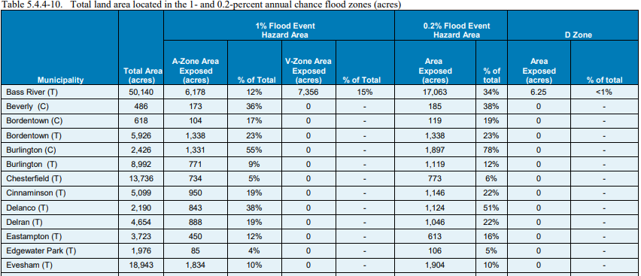

Financial Assessments
- Out of Evesham Township’s Total Improve Value ($4,389,240,875), $36,230,700 of that is in an area exposed to 1-Percent Annual Chance Flood Events, 0.8% in total.

- Out of Evesham Township’s total replacement cost value ($6,451,252,000), $298,462,000 of that is in an area exposed to 1- Percent Annual Chance Flood Events, 4.6% in total. Additionally, the estimated loss of RCV in a possible flood event is $26,706,000 or 0.4% of the township’s total replacement cost value.

- HAZUS-MH estimates the amount of debris generated from the flood events as a result of 1- and 0.2- percent events. This is important because the type of debris a flood creates effects the method and cost of cleanup. The model breaks down debris into three categories: 1) finishes (dry wall, insulation, etc.); 2) structural (wood, brick, etc.) and 3) foundations (concrete slab and block, rebar, etc.). Below is the chart showing Evesham’s estimated flood debris breakdown.
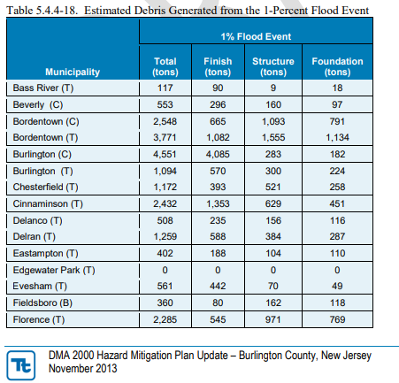

*

Specific Evesham Flooding Events between 1993 and 2013 discussed in Report
- June 19, 2002: Thunderstorms produced very heavy rain across Evesham Township and caused poor drainage and stream flooding. Vehicles were flooded up to their chassis at the Marlton Traffic Circle (intersection of New Jersey State Routes 73 and 70). Doppler Radar storm total estimates reached between 2 and 3 inches in the township, most of which fell in about an hour
- July 14, 2010: For the second consecutive day, thunderstorms with torrential downpours caused flash flooding of smaller creeks as well as urban and poor drainage flooding in southwestern New Jersey. Doppler Radar two day storm total estimates reached as high as 6 inches. Torrential downpours caused the closure of Northbound State Route 73 near Greentree Road in Evesham Twp.
- September 4, 2012 (Hurricane Irene): In Evesham Township, the Township experienced power outages, road closures and damages, and flooding. Residential structures had flood damage. Doppler Radar storm total estimates reached around 10 inches in southeastern Burlington County, more than half of which fell with the first wave of torrential downpours.
- October 26 – November 8, 2012 Hurricane Sandy: In Evesham Township, power outages, road closures and damages, and flooding were all reported. Minor damages were reported to roadways and sidewalks due to downed trees. The MUA pump station experienced minor damage. The Township reported approximately $29K in damages.

Dam failures (F) and damages (D) in Evesham
- Kenilworth #2 Dam (F)
- Crane Lake Dam (F)
- Lost Lake Dam (F)
- Crane Lake Dam (F)
- Elmwood MUA (F)
- Kenilworth Lake Dam (D)
- Kettle Run Road Dam (D)
- Marlton Lakes Upper Dam (D)
- Golf Course Dam (D)
- Union Mill Lake Dam (D)
- Van Dal Lake Dam (D)
(Information from NJDEP Bureau of Dam Safety)

Hammonton
Information from Atlantic County’s Hazard Mitigation report 2015
Link: http://www.atlantic-county.org/documents/hazard-mitigation/2015-Plan-Draft/3A%20ATLANTIC%202015%20HazProf%20DRAFT.pdf
- According to the NCDA (National Climatic Data Center), 96 recorded flood days (coastal flood, flash flood, and flood) have occurred in Atlantic County between January 1996 and June 2015. These events have resulted in more than $357 million in property damages
- Hammonton is on the list of towns with dams that have a high or significant hazard potential. (Hammonton lake Dam / 426 acres) owned by NJDOT
- Hammonton comes up several times on Atlantic County’s Hazard Mitigation report 2015, under the category of Atlantic County significant flooding events
- October 29, 2012. Superstorm Sandy 5.46 inches
- August 2014 3.49 inches
- June 1, 2015 4.6 inches
- June 27, 2015. “Thunderstorms with very heavy rain caused flash flooding of smaller streams as well as poor drainage flooding in northern Atlantic County, mainly in and around Hammonton and Folsom. In Hammonton Township, Packard Street and Bellevue Avenue were closed due to flash flooding (3.49 inches)”

Information from FEMA site on Hammonton
FEMA Floodzone Map
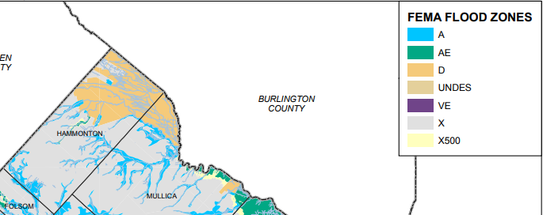
According to the map, most of Hammonton is at risk for some kind of flooding. The majority of Hammonton is located in Zone X, which is defined as areas of moderate flood hazard, usually the area between the limits of the 100‐ year and 500‐year floods. The map also shows the many areas around Hammonton’s multiple waterways that are in Zone A, places with a 1% annual chance of flooding and a 26% chance of flooding over the life of a 30‐year mortgage. The D areas of the map are areas that haven’t been studied or classified.

Information from Model showing future flooding risks
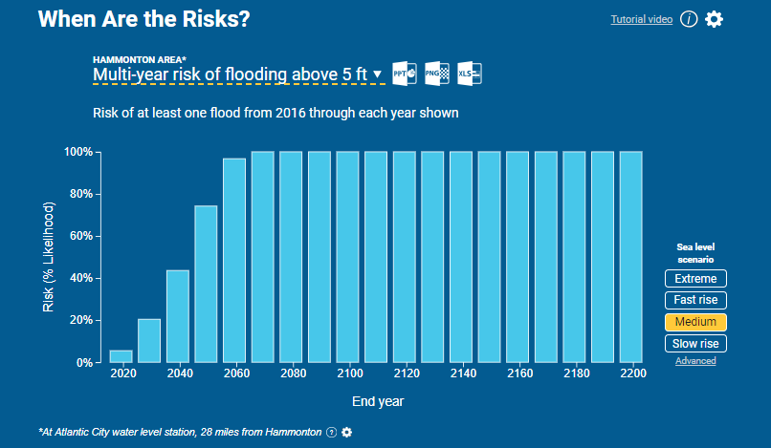
Risk of flooding above 5ft in Hammonton

This analysis uses median local sea level projections based on the intermediate scenario from NOAA Technical Report NOS CO-OPS 083 (2017), and was prepared for the 2018 U.S. National Climate Assessment. It shows the risk of flooding of more than 5 feet occurring in Hammonton due to a medium sea level rise scenario. Already by 2020, these flooding events could occur at a rate of 5% and would jump to a 20% chance by the year 2030. This model for future flooding assumes no future changes in storm patterns. Some climate studies project increasing major storms and surges in some areas, suggesting actual risks in these places to be greater than the model shows.

Link: https://riskfinder.climatecentral.org/search?q=evesham%2C+nj

